**DBMS LAB**

**ASSIGNMENT-3**

**SNEHA SINGH**

**20198023**

**IT 5 B2**

**1.Exercise 1 (practice on SQL commands)**

**2.Assignment on DDL and DML commands**

**A. Suppose that a faculty wants to keep records about the students, the desired records should maintain this information about each student: (Roll No, Full name, CGPA, Age, and Gender)**

**a. Create the appropriate Table.**

**b. Write SQL Queries to answer the following problems:**

**-List the names of all female students.**

**-What is the age of the youngest male student?**

**-List the name and the CGPA for all students who got above 6.5 CGPA ordered by their CGPAs then their names.**

**-What is the Topper name?**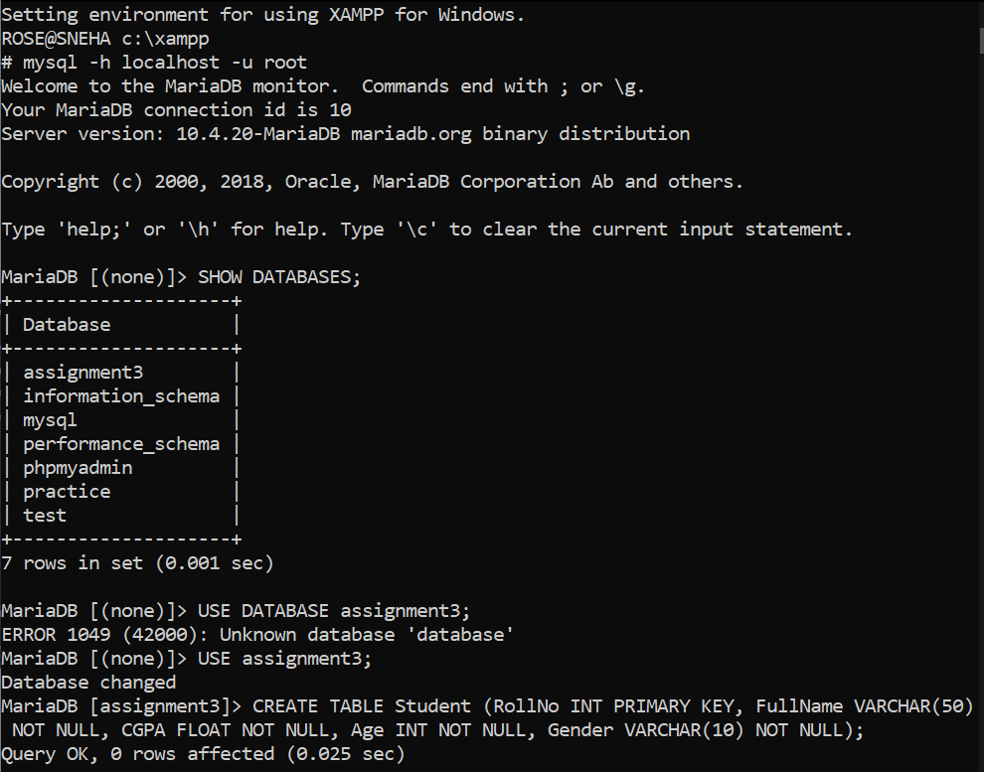

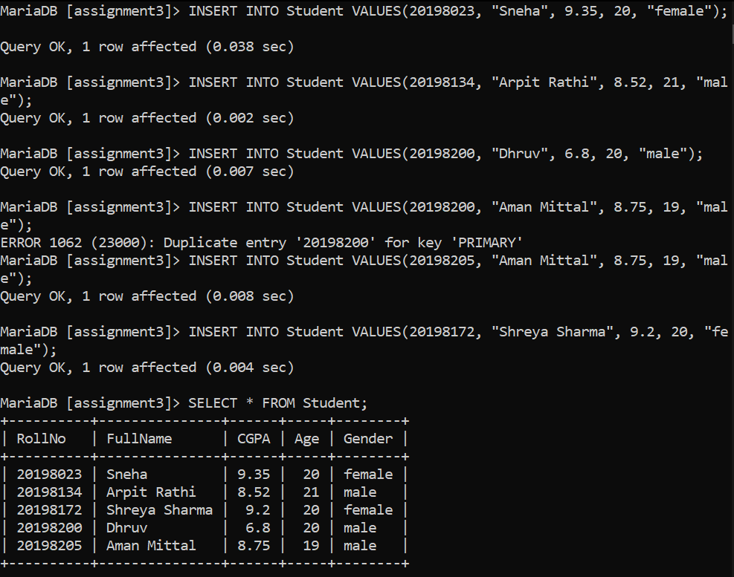

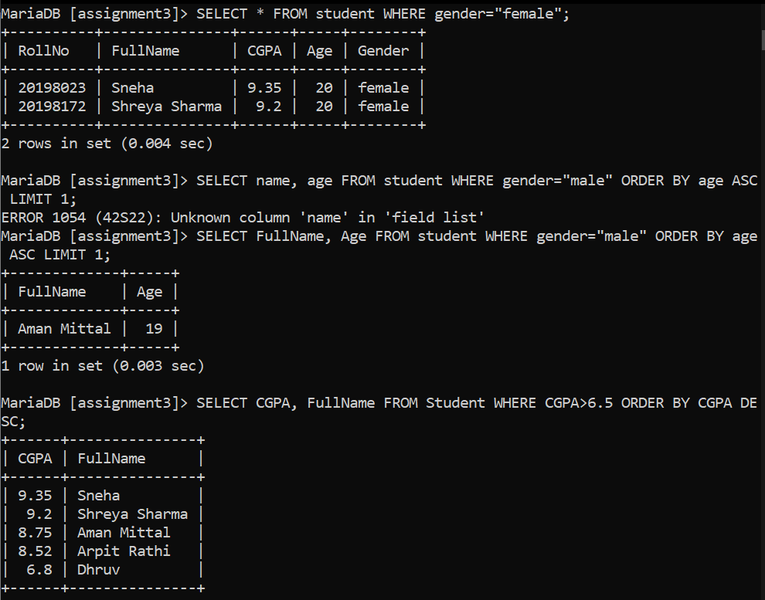

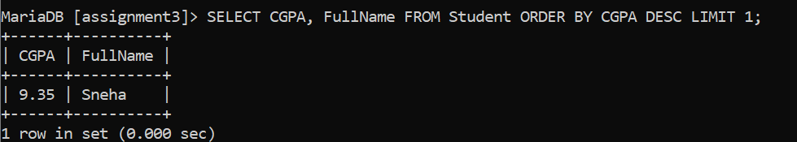

**3.A supermarket manager likes to keep records about all the items in his store these records should hold the following information about each item (the item identifier item_id, the item name, the item price, expiration date of the item, quantity in hand)**

**a. Create the appropriate table.**

**b. Write sql queries to answer the following problems:**

**-List the names and prices for all items that have a quantity in hand>20.**

**-List the names of expired items.**

**-name the second most expensive item.**

**Alter the table structure to make sure that no negative value can be assigned to the price field**

